1. Objective
This report demonstrates the 5 most important security hardening controls applied to a freshly provisioned AWS EC2 Ubuntu instance, using the ec2-ubuntu-harden-top5.sh script. For each control, the system state was captured before and after running the script, providing clear evidence of the security improvement.

2. Methodology
- A new EC2 Ubuntu instance was provisioned with default settings.
- Baseline ("Before") checks were run for each control and the output captured as screenshots.
- The hardening script (ec2-ubuntu-harden-top5.sh) was executed on the instance.
- The same checks were re-run ("After") to confirm the hardened state.
- Screenshots of terminal output are attached as evidence under each control below.

3. Scope of Controls Demonstrated
The following 5 controls, matching the hardening script, are demonstrated below:
- 1. System updates
- 2. Firewall (UFW)
- 3. SSH hardening (root login & password authentication disabled)
- 4. Fail2Ban brute-force protection
- 5. Sensitive file permissions

4. Control-by-Control Evidence

4.1. System Updates
Confirms the system has installed the latest available security patches, closing known vulnerabilities.
Verification command:
apt list --upgradable
Before (Unhardened) | After (Hardened)
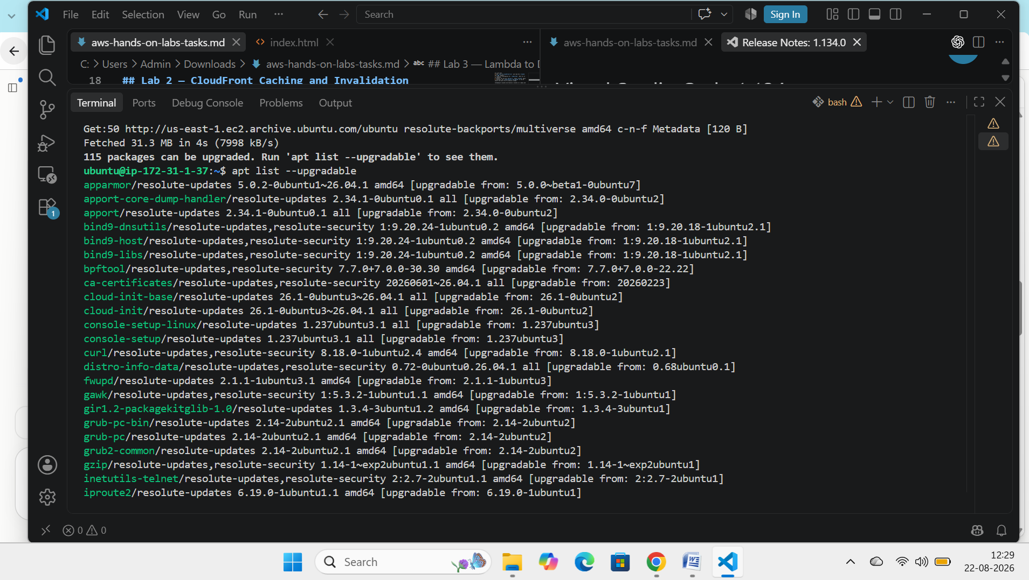 | 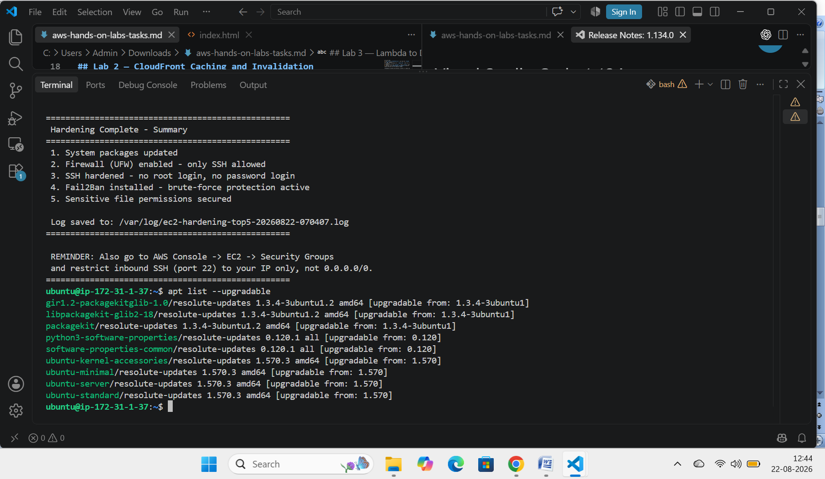
Screenshot / terminal output evidence:
[ Insert BEFORE screenshot here ] [ Insert AFTER screenshot here ]

4.2. Firewall (UFW)
Confirms the host-based firewall is active and only required ports (SSH) are open to the instance.
Verification command:
sudo ufw status verbose
Before (Unhardened) | After (Hardened)
[Paste output: e.g. Status: inactive] | [Paste output: e.g. Status: active, 22/tcp (OpenSSH) ALLOW]
Screenshot / terminal output evidence: 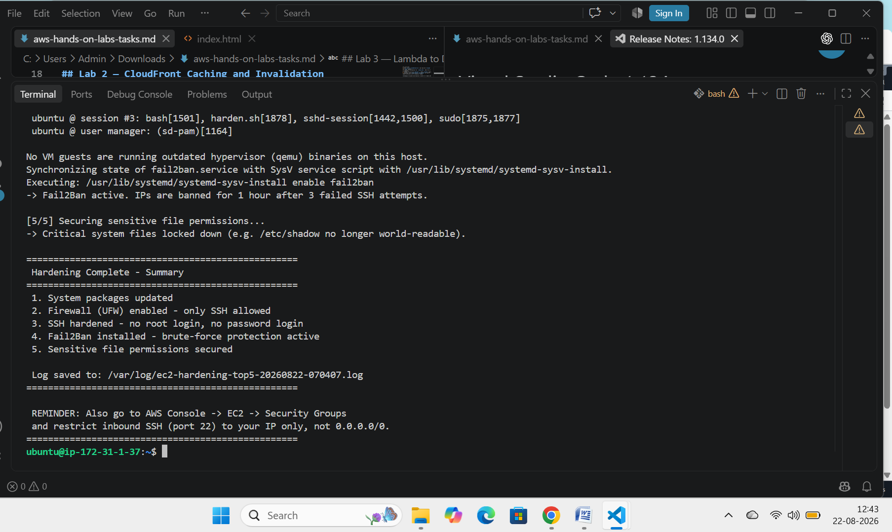

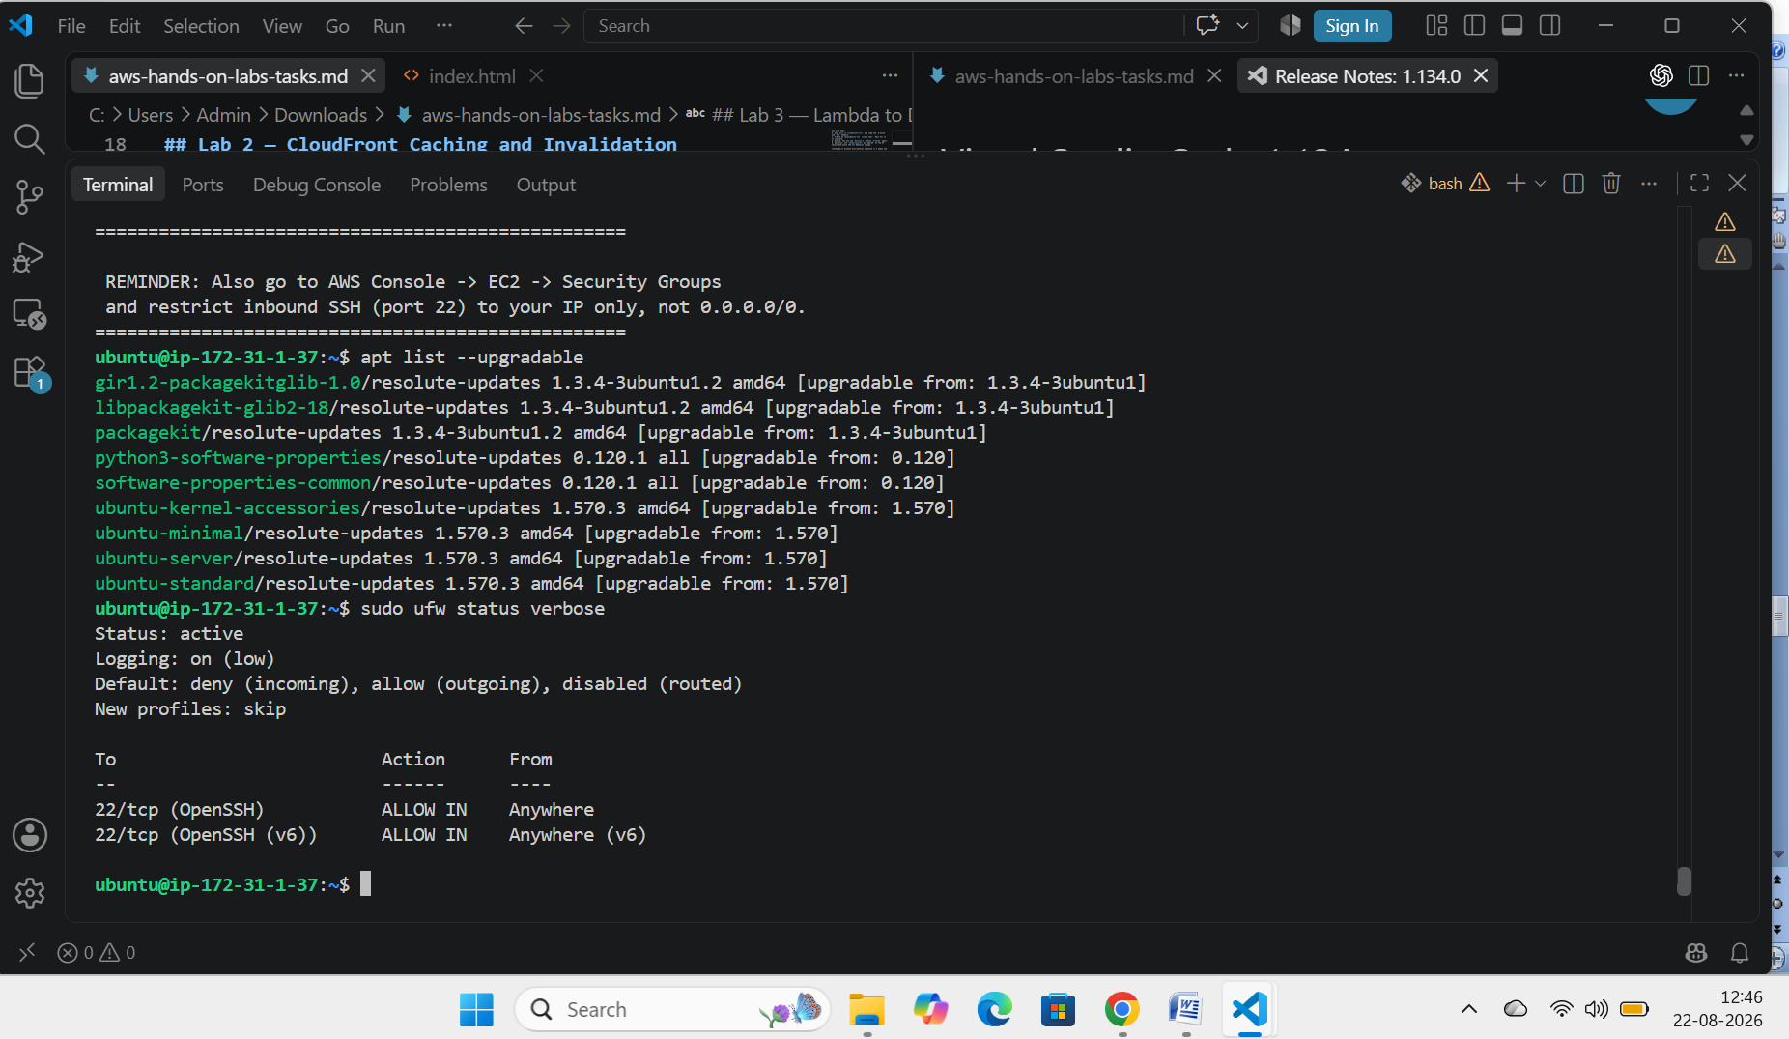4.3. SSH Hardening (Root Login & Password Authentication)
Confirms root cannot log in directly via SSH and password-based login is disabled, requiring SSH key authentication only.
Verification command:
sudo sshd -T | grep -E "permitrootlogin|passwordauthentication"
Before (Unhardened) | After (Hardened)
[Paste output: e.g. permitrootlogin yes / passwordauthentication yes] | [Paste output: e.g. permitrootlogin no / passwordauthentication no]
Screenshot / terminal output evidence:

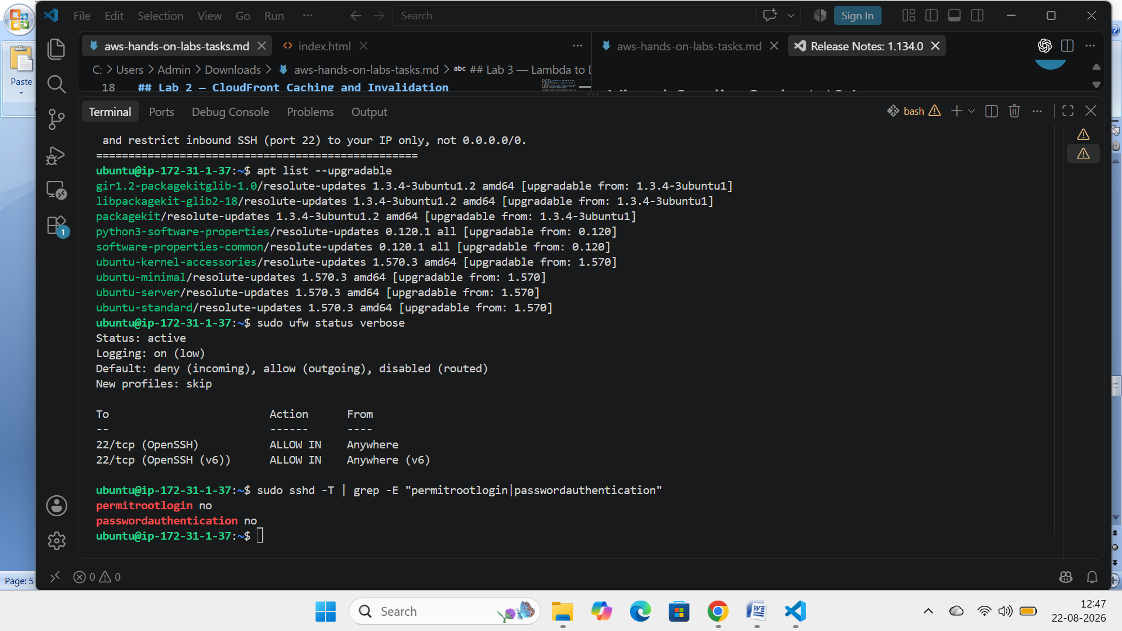4.4. Fail2Ban Brute-Force Protection
Confirms Fail2Ban is running and actively banning IPs after repeated failed SSH login attempts.
Verification command:
sudo systemctl status fail2ban --no-pager && sudo fail2ban-client status sshd
Before (Unhardened) | After (Hardened)
[Paste output: e.g. fail2ban: not installed / inactive] | [Paste output: e.g. Active: active (running), jail: sshd enabled]
Screenshot / terminal output evidence:

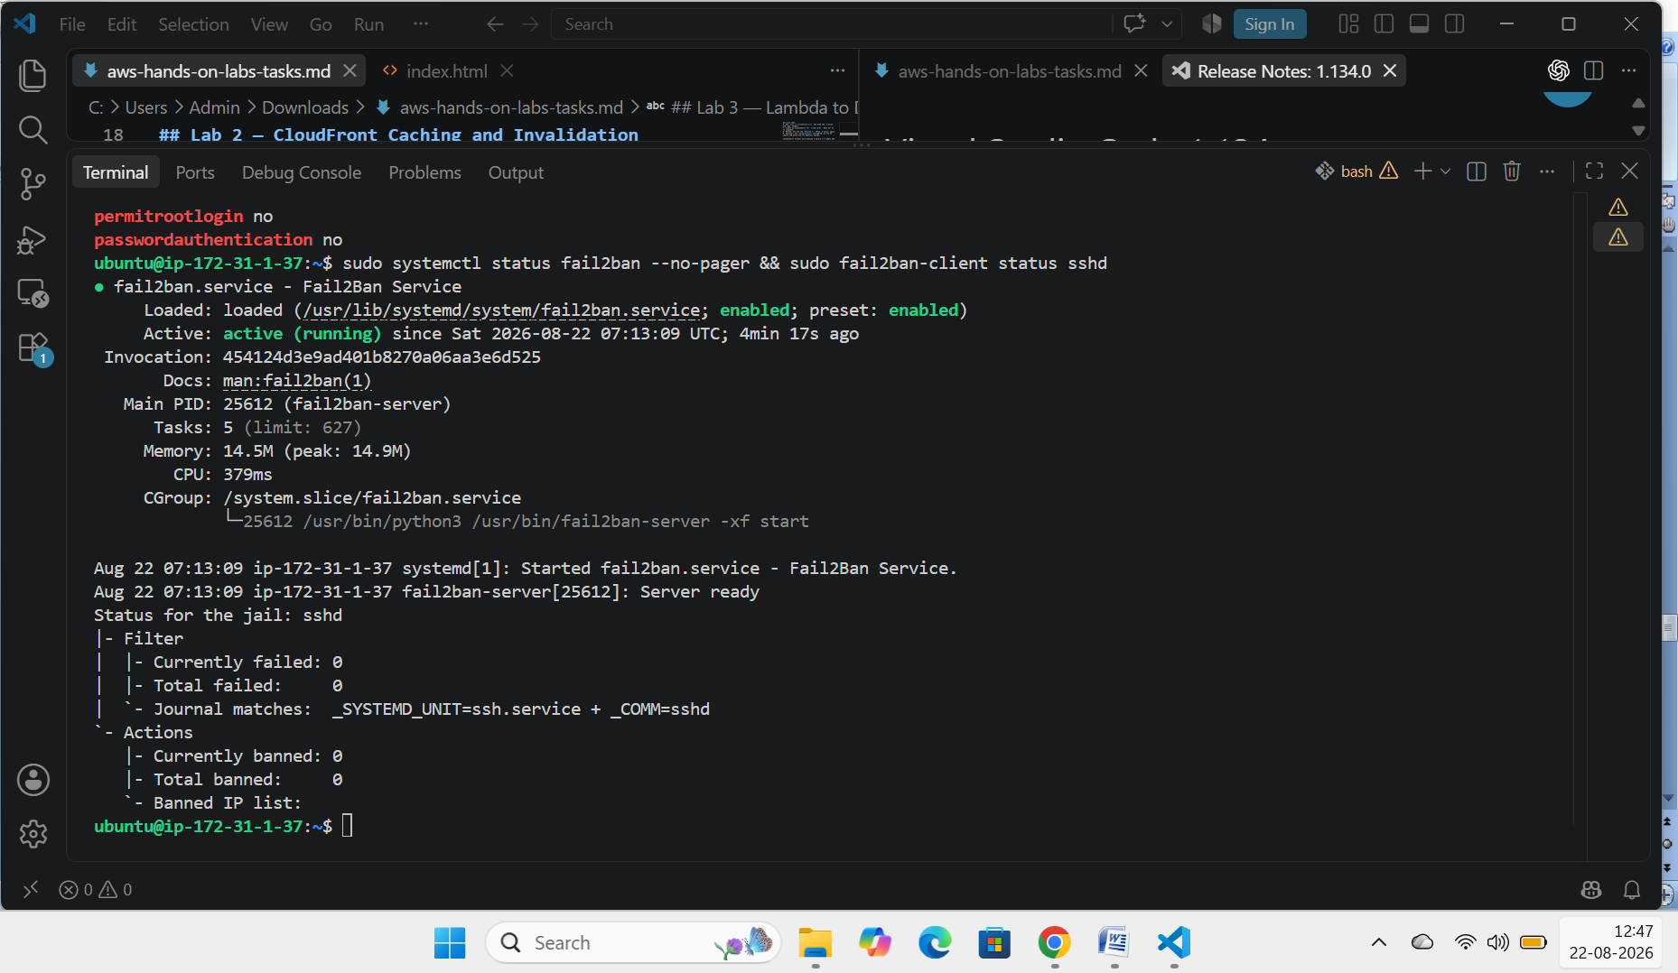 4.5. Sensitive File Permissions
Confirms critical system files (/etc/shadow, sshd_config) are locked down and not accessible to unauthorized users.
Verification command:
ls -l /etc/shadow /etc/ssh/sshd_config
Before (Unhardened) | After (Hardened)
[Paste output: e.g. -rw-r--r-- (world-readable)] | [Paste output: e.g. -rw------- (root only)]
Screenshot / terminal output evidence:
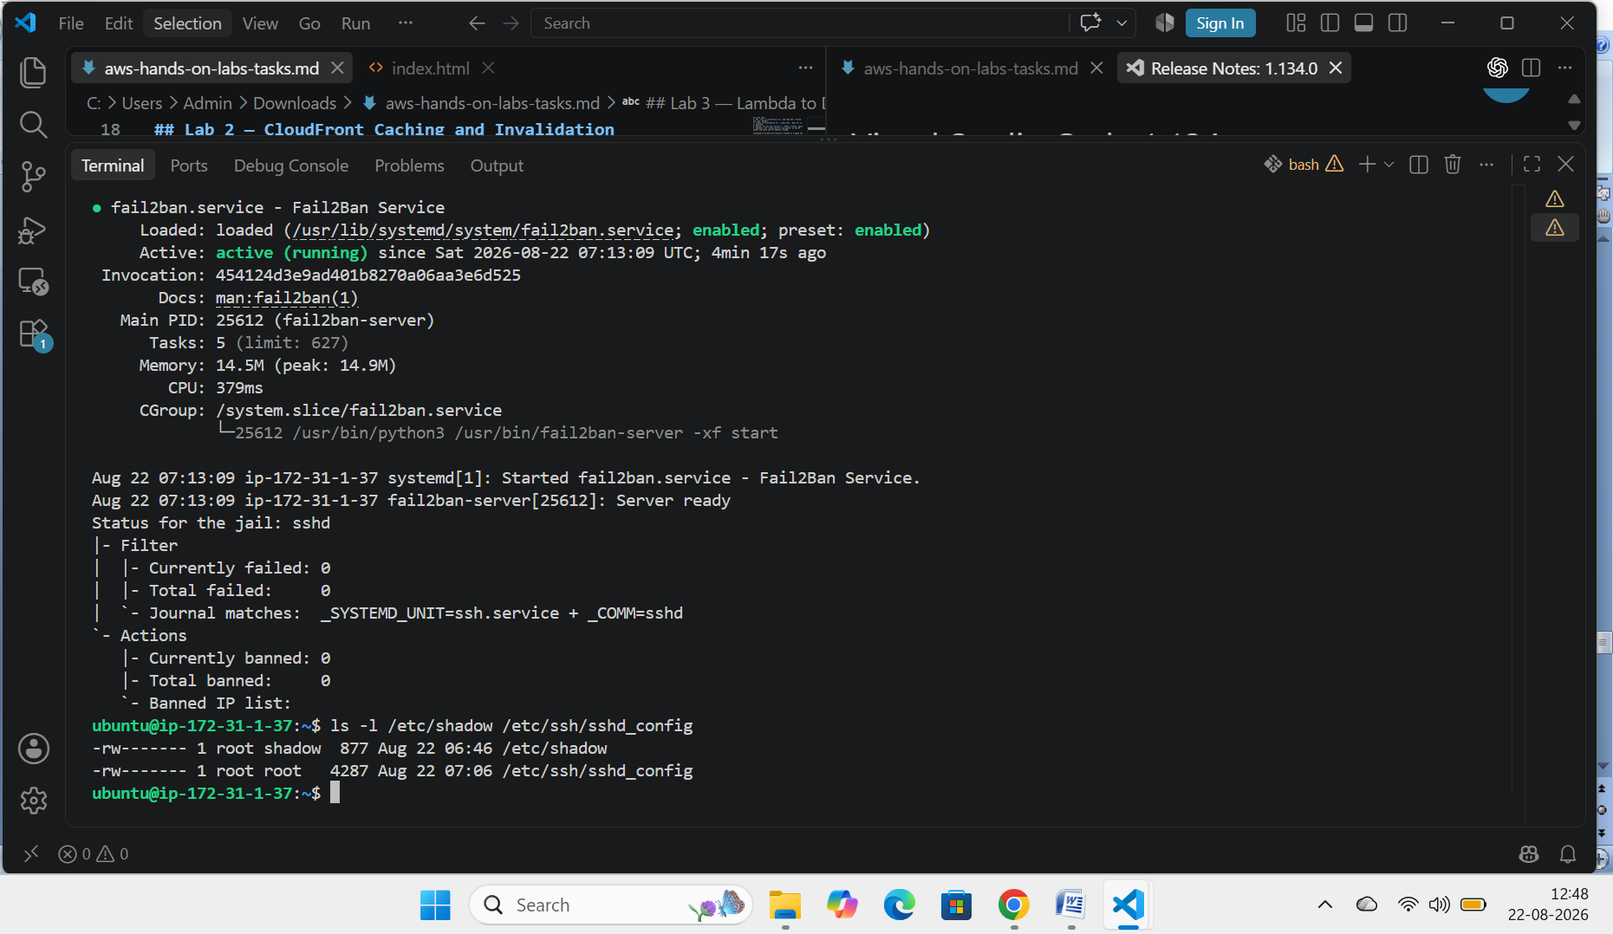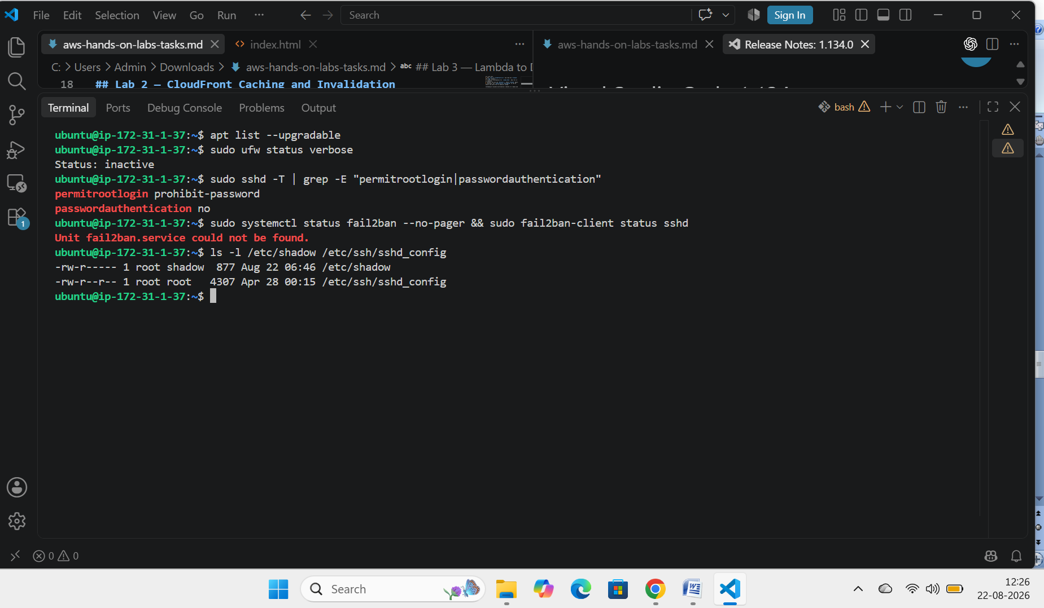 [ Insert AFTER screenshot here ]

5. Summary of Findings
Control | Before | After
System packages updated | ✗ | ✓
Firewall (UFW) active | ✗ | ✓
Root SSH login disabled | ✗ | ✓
Password SSH auth disabled | ✗ | ✓
Fail2Ban active | ✗ | ✓
Sensitive file permissions restricted | ✗ | ✓

6. Conclusion
The hardening script successfully applied the 5 most critical security controls to the EC2 instance, addressing patching, network exposure, remote access authentication, brute-force resilience, and file-level access control. All checks above transitioned from an insecure default state to a verifiable hardened state.

7. Recommended Next Step (Not covered by this script)
Restrict the AWS Security Group's inbound SSH (port 22) rule to your specific admin IP address instead of 0.0.0.0/0. This is configured in the AWS Console, not the OS, and is a critical companion control to the 5 above.

